# A

**PROJECT REPORT**

**ON**

**“Jaap System”**

**SUBMITTED BY**

**Mr. Omkar Kulkarni (SPPU Exam Seat No. 4330)**

**D.Y. PATIL INSTITUTE OF MCA AND MANAGEMENT**

**AKURDI, PUNE-411044**

**Under**

**Savitribai Phule Pune University for Academic Year 2023-2024**

**Acknowledgement**

I would take the opportunity to thank **Dr. K. Nirmala, Director, DYPIMCA and Management** for his support, extended to me throughout the course.

I would like to thank **Dr. Kavita Suryawanshi, Vice Principal,** for her scholarly disposition, timely guidance, support and cooperation.

I would like to thank **Mr. Rahul Chaudhari** for his kind guidance, keen interest, continuous encouragement and inspiration throughout the project work.

Finally, I gratefully thank all the faculty members of DYPIMCA and Management for their cooperation and support.

I also thankful to get constant encouragement, support and guidance from all Teaching and Non- Teaching Staff for their timely support which helped us in successfully completion of our project work.

Student Sign:

Student Name: Omkar Kulkarni

MCA II

Div- A

Roll No.: 38

SPPU Seat No.: 4330

|  |  |  |  |  |  |
| --- | --- | --- | --- | --- | --- |
| **Dr. D. Y. Patil Pratishthan’s**  **D. Y. Patil Institute of Master of Computer Applications and Management**  **(M.C.A. Programme)**  (Approved by AICTE, New Delhi & Affiliated to Savitribai Phule PuneUniversity)  **Dr. D. Y. Patil Educational Complex, Sector 29, Pradhikaran, Akurdi, Pune – 411 044**Tel No: (020)27640998, Website: [www.dypimca.ac.in,](http://www.dypimca.ac.in/) E-mail : [director@dypimca.ac.](mailto:director@dypimca.ac) | | | | | |
|  | **Index** | | | | |
|  | | Sr. No | Chapter Name | Page No |  |
| **1** | **Chapter 1: Introduction** | 1 |
| 1.1 | Company Profile | 2 |
| 1.2 | Project Abstract | 3 |
| 1.3 | Existing System and Need of System | 4 |
| 1.4 | Scope of System | 5 |
| 1.5 | Operating Environment-Hardware and Software | 5 |
| 1.6 | Technology Used | 5 |
| **2** | **Chapter 2: Proposed System** | 6 |
| 2.1 | Proposed System | 7 |
| 2.2 | Feasibility Study | 8 |
| 2.3 | Objectives of System | 9 |
| 2.4 | Users of System | 10 |
| **3** | **Analysis and Design** | 12 |
| 3.1 | Entity Relationship Diagram (ERD) | 13 |
| 3.2 | Data Flow Diagrams | 13 |
| 3.4 | Use Case Diagram | 15 |
| 3.5 | Class Diagram | 16 |
| 3.6 | Deployment Diagram | 17 |
| 3.7 | Activity Diagram | 18 |
| 3.8 | Table Structure | 20 |
| 3.9 | Sample Input Output Screens | 23 |
| **4** | **Coding** | 30 |
| 4.1 | Code Snippets | 31 |
| **5** | **Testing** | 33 |
| 5.2 | Unit Test Plan | 34 |
| 5.4 | Test Cases | 35 |
| **6** | **Limitations of Proposed System** | 37 |
|  | | | | | |

|  |  |  |
| --- | --- | --- |
| **7** | **Proposed Enhancement** | 39 |
| **8** | **Conclusion** | 41 |
| **9** | **Bibliography** | 43 |
| **10** | **Appendix- Cost Sheet** | 45 |

**Chapter 1: Introduction**

**Company Profile**

**Company Name:** NS Compwares

**Owner Name:** Nilesh Mahale

**Business Overview**

NS Compwares specializes in providing comprehensive IT solutions, including software

development, IT consulting, and digital services. The company focuses on leveraging

advanced technologies to deliver customized solutions that meet the specific needs of its clients.

**Services Offered**

NS Compwares, based in Pimpri, Maharashtra, offers a wide range of IT services designed to meet

the diverse needs of its clients. Here is an overview of the key IT services provided by the company.

1. **Web Development:** NS Compwares specializes in developing responsive and visually appealing

websites and web applications. They ensure these web solutions are not only user-friendly but

also optimized for performance and security. Their services include complete lifecycle management

from design to deployment and maintenance on cloud platforms.

1. **Mobile Application Development:** The company develops both hybrid and native mobile

applications tailored to client needs. Their mobile solutions are designed to integrate seamlessly

with hardware and provide a robust user experience.

1. **Micro Works:** They offer expert assistance for specific problems or setups that clients face. This

could involve configuration issues, coding problems, or maintenance tasks. Their team provides

targeted help to resolve these challenges effectively.

.

# Project Abstract

## Recognizing the importance of spiritual practices in maintaining mental well-being, the Jaap System ‑provides a digital platform for users to engage in the ancient practice of chanting mantras. Rooted in Hindu traditions, jaap refers to the repetition of a specific mantra or prayer, believed to have profound spiritual benefits. This project harnesses the power of technology to facilitate and enhance the spiritual journey of members, offering them a structured way to track and engage in their chosen mantra practice.

**Problem Statement:**

In modern society, individuals face numerous challenges that affect their overall well-being, including stress, anxiety, and a lack of spiritual connection. While spiritual practices such as meditation and prayer offer potential solutions, many people struggle to integrate these practices into their daily lives due to various constraints such as time, accessibility to spiritual resources, and lack of accountability. Additionally, traditional methods of tracking spiritual progress, such as pen and paper, may be cumbersome and prone to error. Thus, there exists a need for a digital solution that not only facilitates spiritual practices but also provides users with the tools to monitor and improve their engagement over time. It is very difficult to maintain historical data.

# Existing System

The existing system is very tedious as it involves the manual data storage. Also maintaining the customer records through files and books is tedious job. We can imagine that as the information storage is there, it requires the various data stores which may be registers or diaries to note the respective details. And from these data stores the retrieval of required information is also difficult as we have to search all the records until we do not get the desired information. So, to avoid all these problems this project is required. Moreover, without an external tracking system, practitioners may struggle to maintain consistency, leading to gaps in their spiritual journey. While manual recording offers privacy, physical journals are vulnerable to loss, damage, or unauthorized access, posing potential security risks to personal practices.

# The following are the disadvantages of the existing system

* + - It is tedious to manage historical data which needs much space to keep all the previous year data.
    - Monthly counts details must be entered into books are very difficult to maintain**.**
    - It is difficult to maintain important information in books.

# Need for System

* **Simplify Tracking:** A digital platform simplifies the process of recording and tracking jaaps, eliminating the need for pen and paper and reducing the potential for errors.
* **Improve Accessibility:** Users can access their jaap records anytime and anywhere, providing greater flexibility and convenience.
* **Enhance Accountability:** By allowing users to subscribe to jaaps and view progress, the system encourages regular practice and accountability.
* **Maintain Historical Data:** The system ensures that historical data is recorded and easily retrievable, enabling users to inspect their spiritual journey and progress in time.
* **Foster Community Engagement**: Community features such as commenting and sharing progress allow users to connect with others, fostering a sense of community..

# Scope of Work

* Members can register and authenticate their accounts securely.
* Jaaps can be created by users and viewed to by others.
* Members can enter and edit jaap counts, ensuring accurate tracking.
* Aggregated data shows the total jaap counts across all users.
* Users can manage the profiles, updating information as needed.
* Users have access to an admin panel for system management and moderation duties.

# Operating Environment

## Hardware

* RAM: Minimum 2 GB.
* Disk Space: Minimum 1GB.
* Processor: Pentium-2, 3, 4 and above.

## Software

* Operating System: Windows 7 & above.
* Front end: HTML, CSS and JavaScript.
* Backend: Php
* Database: MySQL
* Tools: VS code and Xamp.

# Modules of System:

* User Management.
* Member Management.
* Subscription Management.
* Jaap Management.
* Jaap Count Management.
* Community Progress Management.

**Chapter 2: Proposed System**

# Proposed System

# Member Registration and Authentication:

# Member can create accounts on the platform securely and authenticate themselves to access the system's features.

# Jaap Creation and Customization:

# Users have the flexibility to create personalized jaaps, specifying the mantra, start date, end date, and any additional details relevant to their spiritual practice.

# Jaap Subscription and Management:

# Member can browse and subscribe to existing jaaps created by User, enabling them to participate in communal spiritual practices and receive updates on their progress.

# Jaap Count Tracking and Editing:

# The system allows Members to enter their jaap counts for subscribed jaaps on a monthly basis, with options to edit or update counts as needed.

# Reporting and Analytics:

# Users can track jaap counts over time, providing insights progress to spiritual practices.

# The system aggregates jaap counts from all users, offering Users valuable analytics to monitor user engagement and community trends.

# Admin Panel for System Management:

# Users have access to a dedicated admin panel for managing Members and Users accounts, overseeing jaap creation and moderation, and ensuring the overall integrity and security of the system

# Privacy and Security Measures:

# The system implements robust privacy and security measures to safeguard user data and ensure confidentiality, including encryption protocols and access controls.

# Scalability and Future Enhancements:

# The proposed system is built with scalability in mind, capable of accommodating a growing user base and incorporating future enhancements based on user evolving spiritual practices.

**Feasibility Study**

**1. Technical Feasibility**

* Technology Stack:
  + The project uses HTML, CSS, and PHP, which are well-established, widely supported, and have a large developer community. These technologies are suitable for building web applications.
  + MySQL is used for the database, which is reliable, scalable, and integrates well with PHP.
  + Standard tools and environments such as Apache for web serving, and IDE like VS Code for coding.A database server (such as MySQL) for storing user data and jaap records.

**2. Operational Feasibility**

* User-Friendly Interface:
  + The system should have an intuitive and easy-to-navigate user interface. Using HTML and CSS will allow for responsive and user-friendly design.
* Maintenance:
  + Regular updates and maintenance are necessary to ensure the system runs smoothly. This includes security patches, feature updates, and bug fixes.
* Training and Support:
  + Users and administrators will need minimal training due to the intuitive design of the system. Documentation and support can be provided for troubleshooting common issues.

**3. Economic Feasibility:**

* + Development costs include the salaries of developers, designers, and project managers, as well as the cost of software tools if any are not open source.
* Hosting and Maintenance Costs:
  + Web hosting and database server costs, which could be minimized using affordable cloud services like AWS, DigitalOcean, or shared hosting platforms.
  + The system could potentially be monetized through subscription models, ads, or providing a return on investment.

**4. Legal Feasibility:**

* Data Protection and Privacy:
  + Compliance with data protection regulations such as GDPR is essential. User data must be securely stored and managed.

# Objectives of the System

1. To provide users with a user-friendly and intuitive platform for engaging in spiritual practices, specifically the chanting of mantras or jaaps.
2. To enable users to set personal jaap goals, track their progress over time, and receive encouragement and support from a community of like-minded individuals.
3. To facilitate accountability and motivation by allowing users to subscribe to specific jaaps, enter monthly jaap counts, and view their total jaap counts over time.
4. To offer administrators the tools to manage and moderate the system effectively, ensuring a positive and enriching user experience for all participants.

# Users of System

# There are two types of users present in this application

# • User (Admin)

# • Member (User of System)

# Here is a detailed user tour:

# User (Admin):

# Login:

# Users can log in using their credentials, providing access to the full range of application features.

# User Management:

# Admins can manage user accounts, including viewing, editing, and deleting user information, ensuring smooth operation and user support.

# Jaap Creation:

# Users can create new jaaps by specifying a mantra, start date, and end date, allowing for personalized spiritual practices.

# Jaap Management:

# Admins can view, approve, edit, or delete jaaps created by users, maintaining the integrity and appropriateness of the content within the system.

# Data Reporting and Analytics:

# Admins can access reports and analytics on jaap counts and user engagement, providing insights for improving the system and supporting users in their practices.

# System Maintenance:

# Admins are responsible for maintaining the system, including updates, backups, and troubleshooting technical issues to ensure the platform runs smoothly and securely.

# Member (User of System):

# Registration/Login:

# Users can create an account or log in using their credentials, providing access to the full range of application features.

# Jaap Subscription:

# After logging in, users can browse and subscribe to available jaaps that they are interested in, enabling them to participate in communal spiritual practices

# Jaap Count Entry and Editing:

# Users can enter their jaap counts for the subscribed jaaps for a particular month and edit these counts as needed, ensuring accurate tracking of their progress.

# View Community Progress:

# Users can view their total jaap counts and progress over time, providing insights into their spiritual journey and motivation to maintain consistency

# User Requirements

* + Basic knowledge of computer or mobile.
  + Device with internet Connectivity.
  + Must have Basic knowledge of English.

**Chapter 3: Analysis and Design**

**Entity Relationship Diagram**

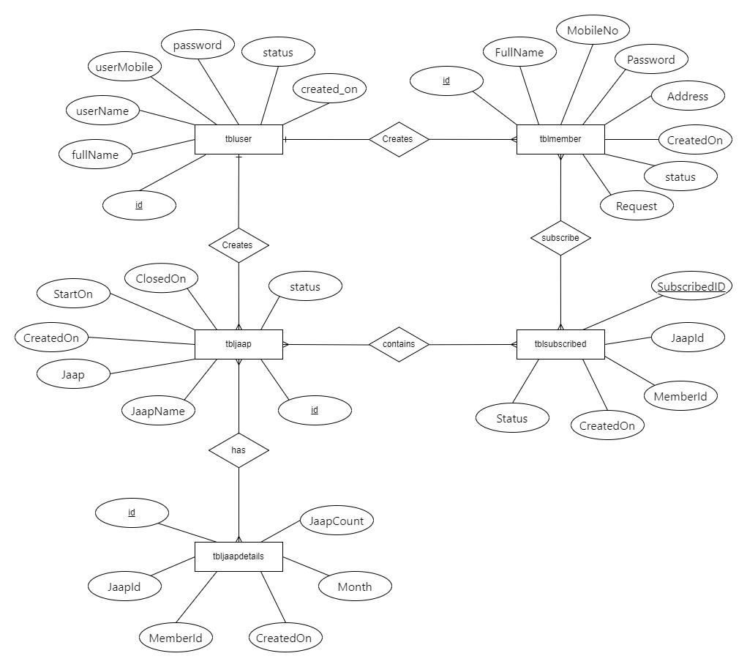

**DFD (Context Level)**

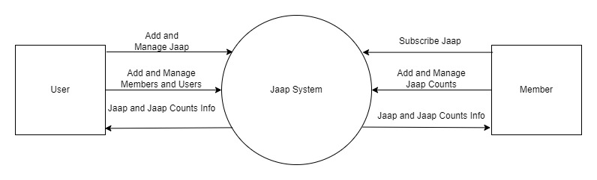

**1st Level DFD**

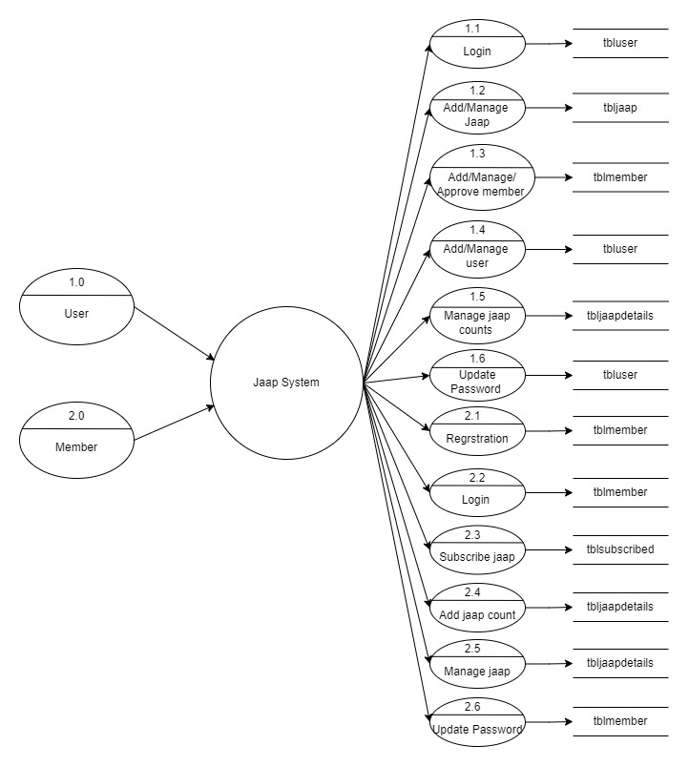

**USE-CASE Diagram**

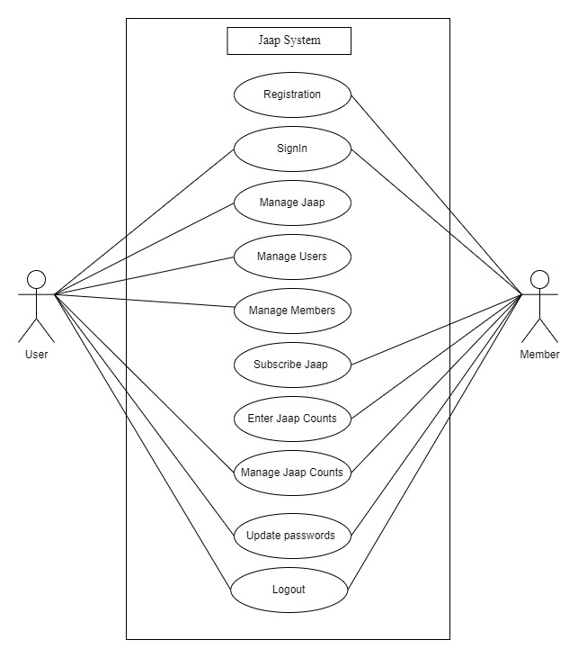

**Class Diagram**

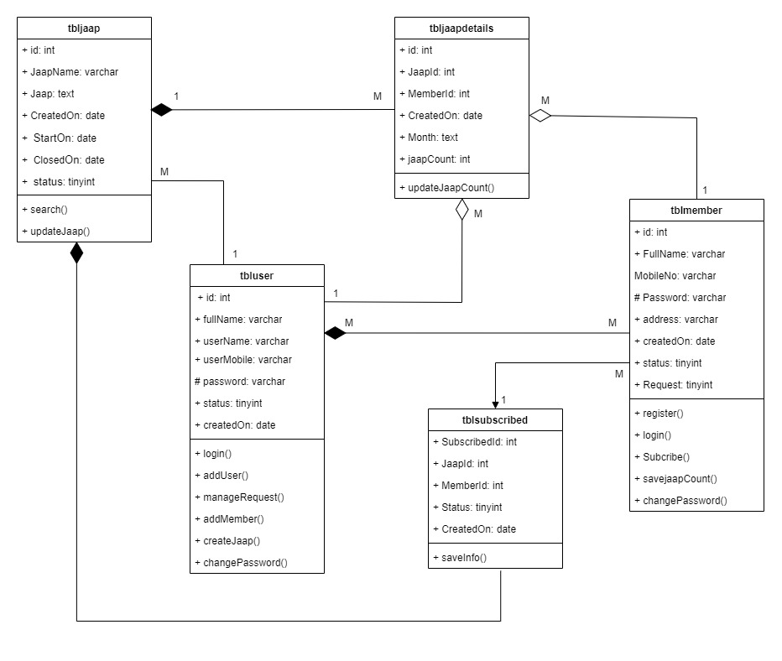

**3.4 Deployment Diagram**

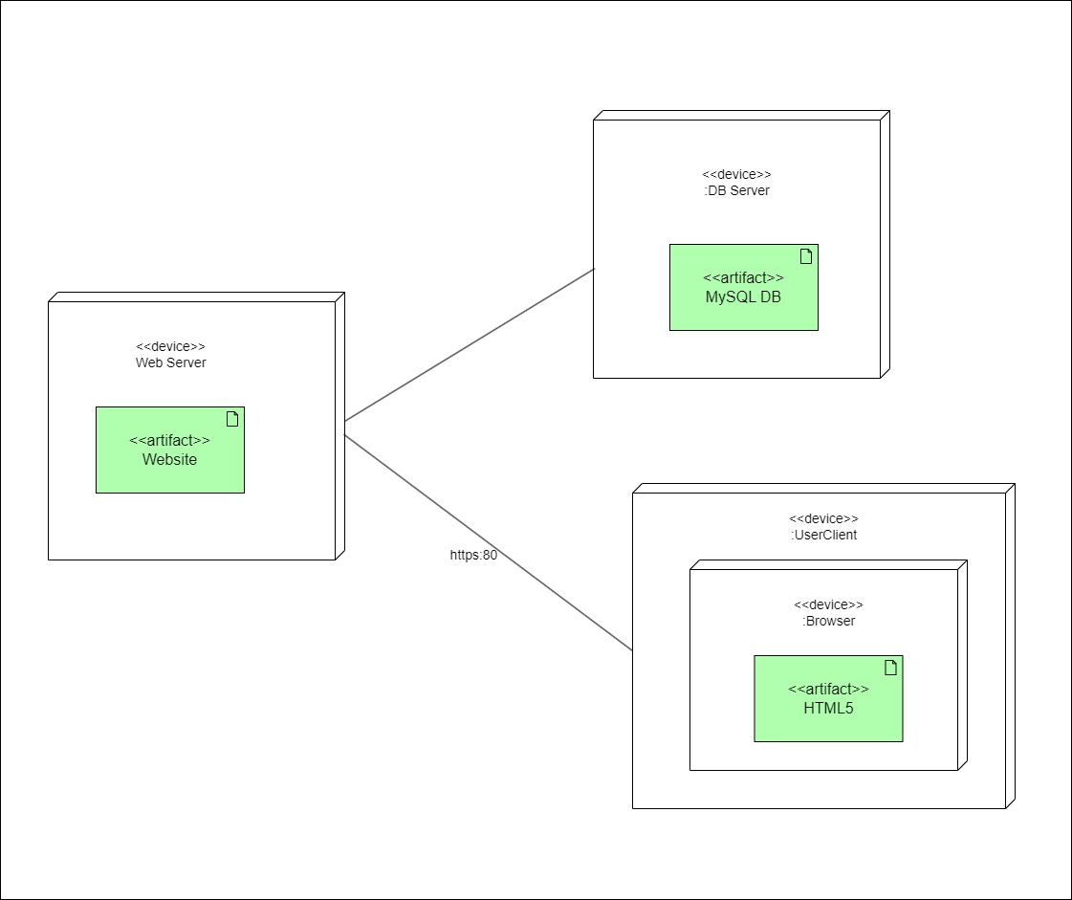

**3.6 Activity Diagram**

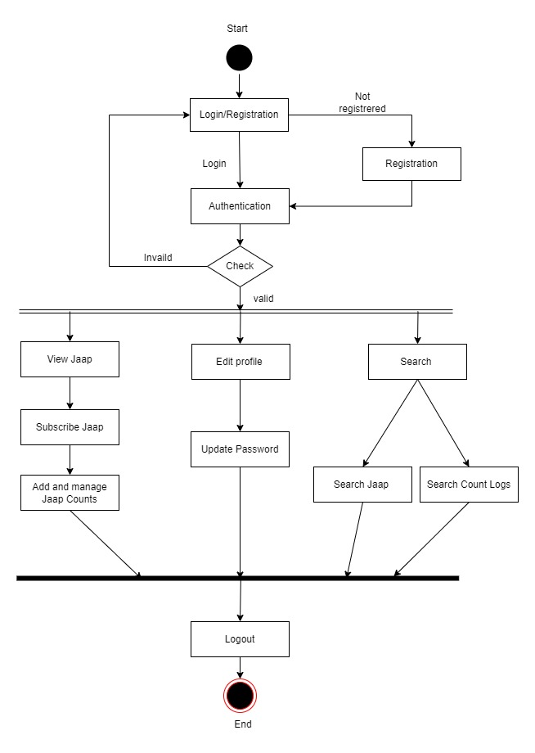

**Member Activity Diagram**

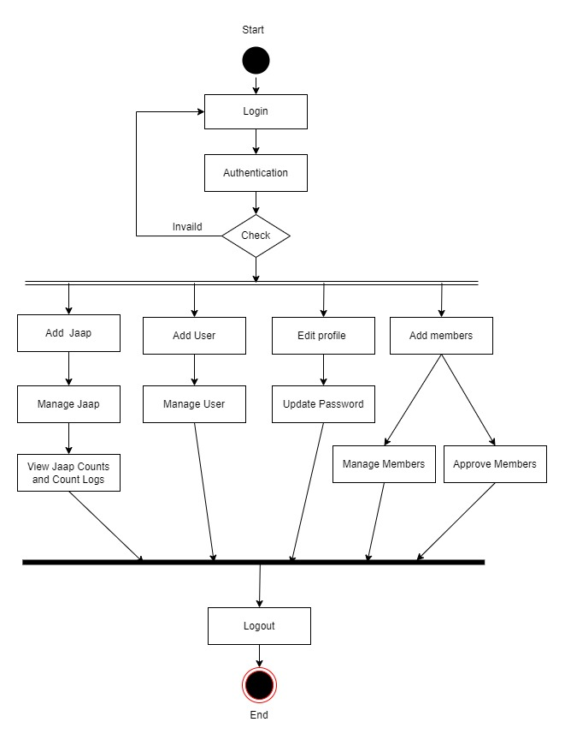

**User Activity Diagram**

**Table Design:**

* **tbljaap:**

|  |  |  |  |
| --- | --- | --- | --- |
| **Field name** | **Data Type** | **Constraints** | **Description** |
| id | Int(11) | Primary key | Unique id for Jaap |
| JaapName | varchar(255) | Not null | Name of jaap |
| Jaap | text | Not null | Jaap for chanting |
| CreatedOn | date | Not null | Date and time of jaap creation |
| StartOn | date | Null | Date of jaap to be started on |
| ClosedOn | date | Null | Date of jaap creation to be closed on |
| status | tinyint | Not null | Status of jaap: 0= incomplete,1= complete |

* **tbluser:**

|  |  |  |  |
| --- | --- | --- | --- |
| **Field name** | **Data Type** | **Constraints** | **Description** |
| id | Int | Primary key | Unique id for Jaap |
| FullName | varchar(255) | Not null | Name of user |
| userName | varchar(255) | Not null | User name of an user |
| userMobile | varchar(255) | Not null | Phone no. of an user |
| password | varchar(255) | Not null | Password of user |
| status | Tinyint(4) | Not Null | Status of user: 0=active, 1=banned |
| created_on | date | Not Null | Date of user creation |

* **tblmember:**

|  |  |  |  |
| --- | --- | --- | --- |
| **Field name** | **Data Type** | **Constraints** | **Description** |
| id | Int(11) | Primary key | Unique id for Jaap |
| FullName | varchar(150) | Not null | Name of member |
| MobileNo | varchar(50) | Not null | Phone no. of an member |
| Password | varchar(1000) | Not null | Password of member |
| Address | Text | Not null | Address of member |
| CreatedOn | date | Not Null | Date of member creation |
| status | Tinyint(1) | Not Null | Status of member: 0=active, 1=banned |
| Request | Tinyint(4) | Not Null | Status of Request:  0=pending, 1=approved |

* **tbljaapdetails:**

|  |  |  |  |
| --- | --- | --- | --- |
| **Field name** | **Data Type** | **Constraints** | **Description** |
| id | Int(11) | Primary key | Unique id of jaapdetails |
| JaapId | Int(11) | Foreign key | Unique id of Jaap |
| MemberId | Int(11) | Foreign key | Unique id of member |
| CreatedOn | date | Not null | Date of details created |
| Month | text | Not null | Name of Month for jaap count submitted |
| JaapCount | Int(11) | Not null | Number of jaap counts chanted. |

* **tblsubscribed:**

|  |  |  |  |
| --- | --- | --- | --- |
| **Field name** | **Data Type** | **Constraints** | **Description** |
| SubscribedID | Int(11) | Primary key | Unique id of subscription |
| JaapId | Int(11) | Primary key | Unique id of Jaap |
| MemberId | Int(11) | Primary key | Unique id of member |
| CreatedOn | Datetime | Not null | Date of subscription done. |
| status | Tinyint(4) | Not null | Status of subscription : 0=Unsubscribe, 1=Subscribe |

# 3.8 USER INTERFACE:

Flash Screen:

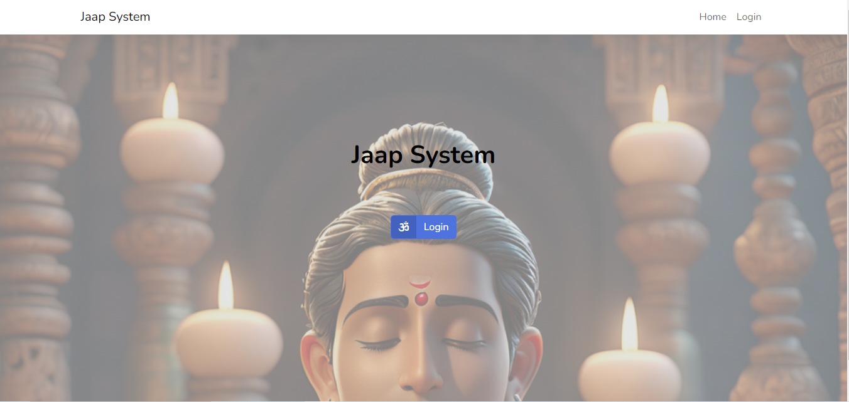

Registration Page: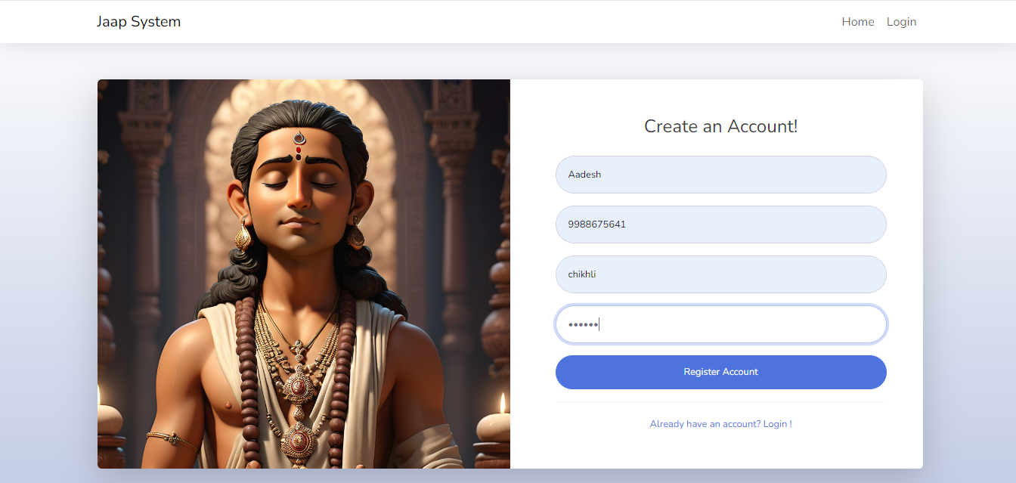

Login Page:

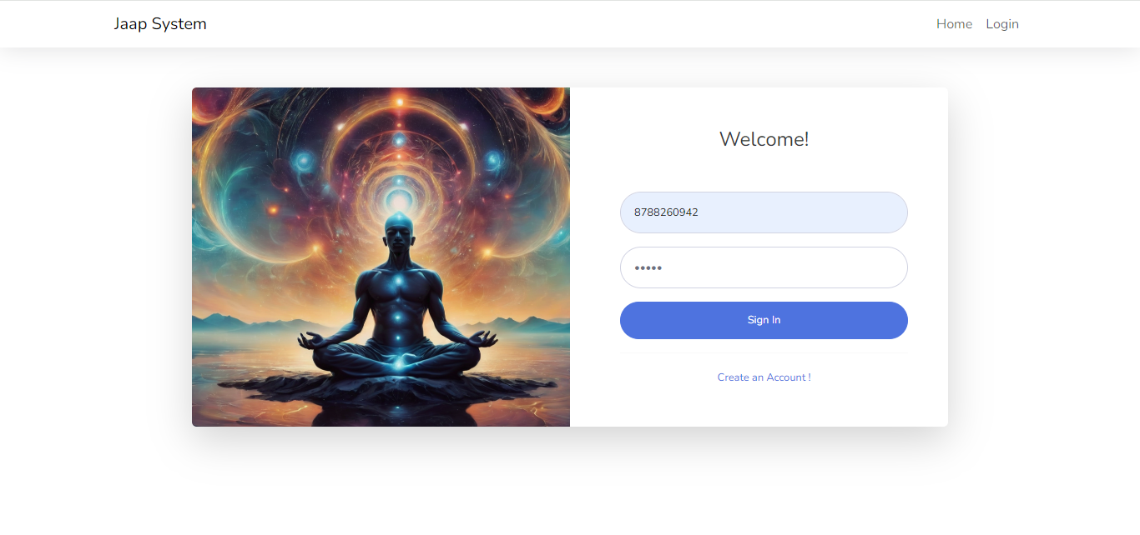

Admin Dashboard:

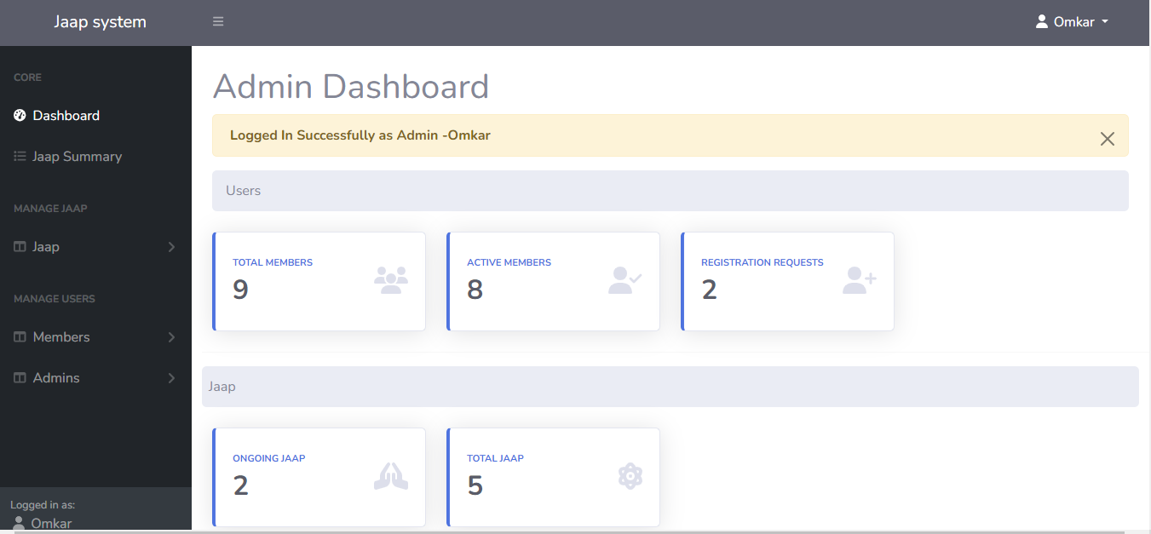

Create Jaap:

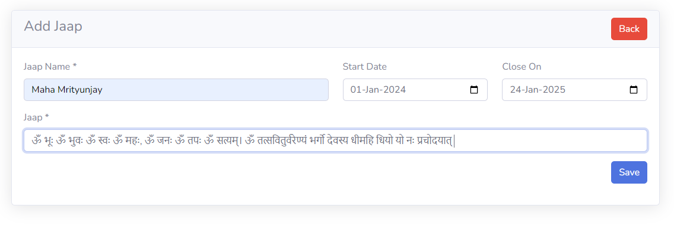

Add Admin:

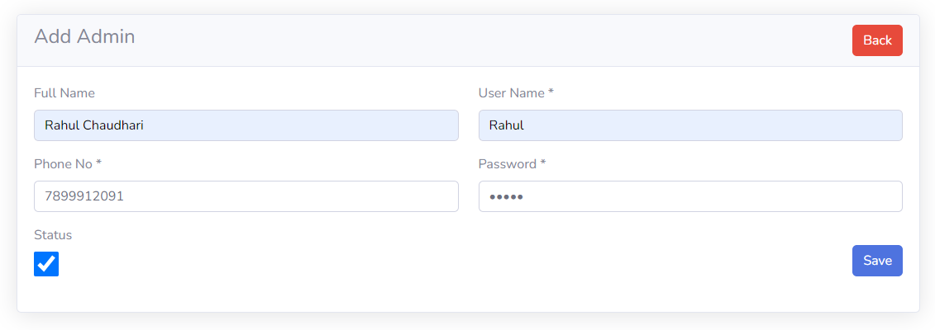

View Admin:

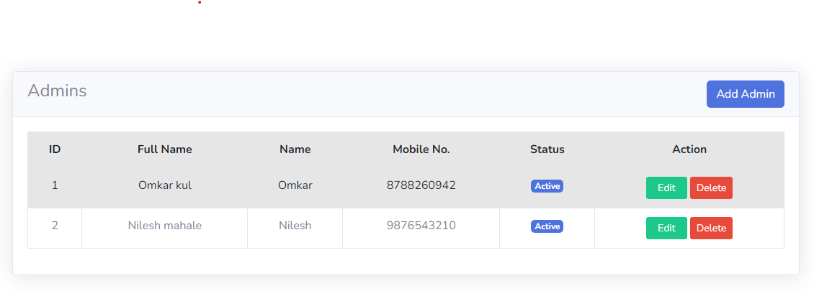

Add Member:

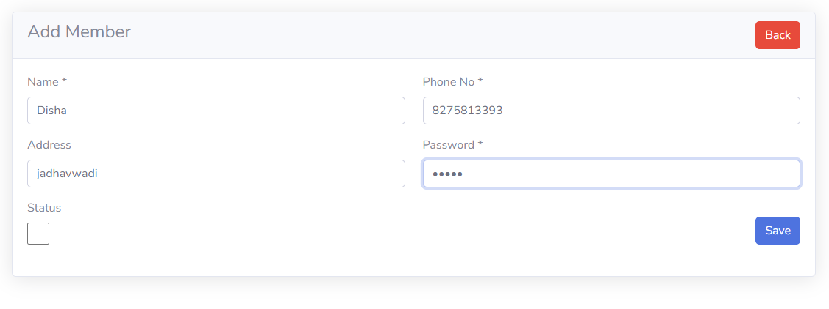

View Member:

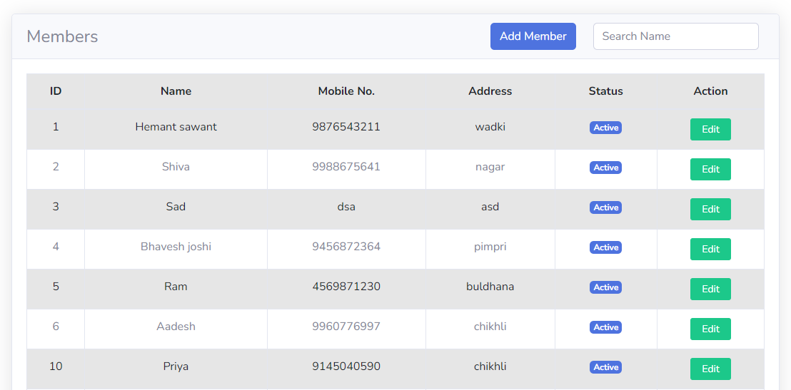

Approve Members:

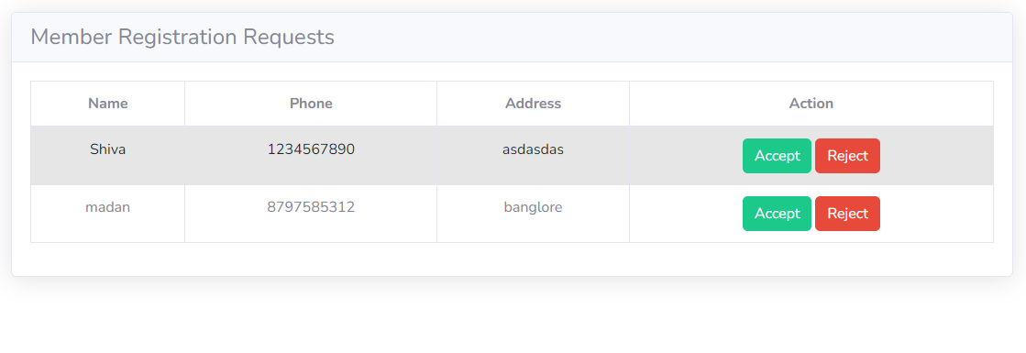

Jaap Count Details:

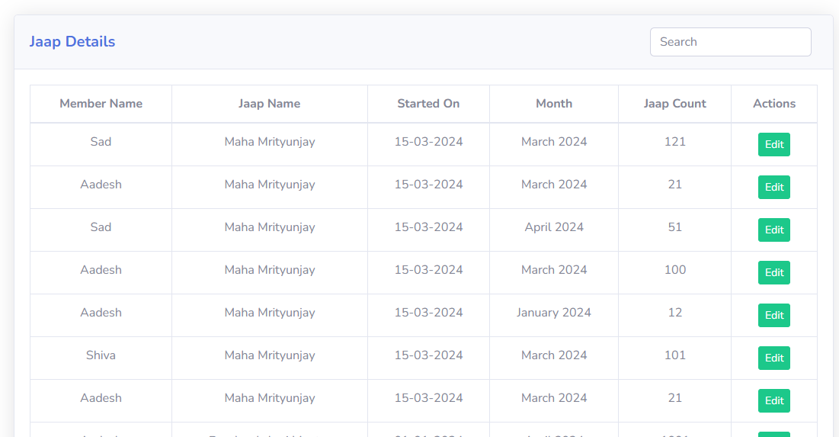

Change Password:

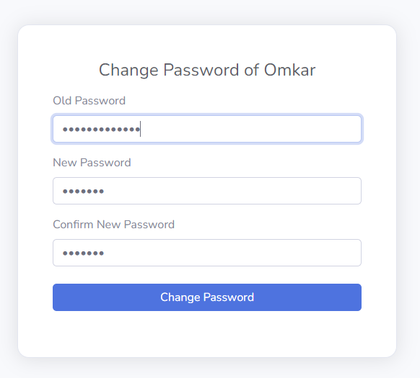

Subscribe Jaap:

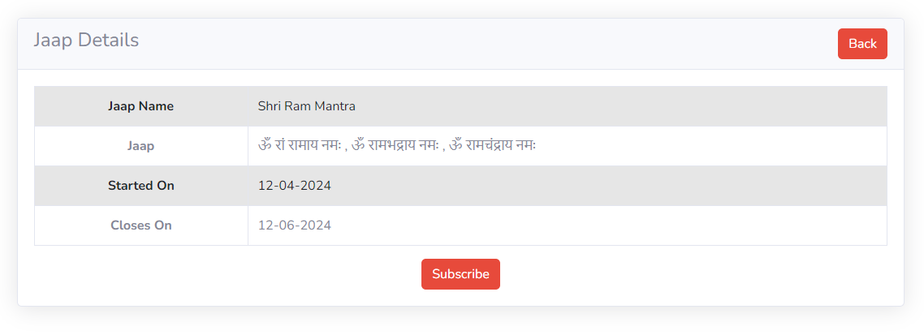

Donations 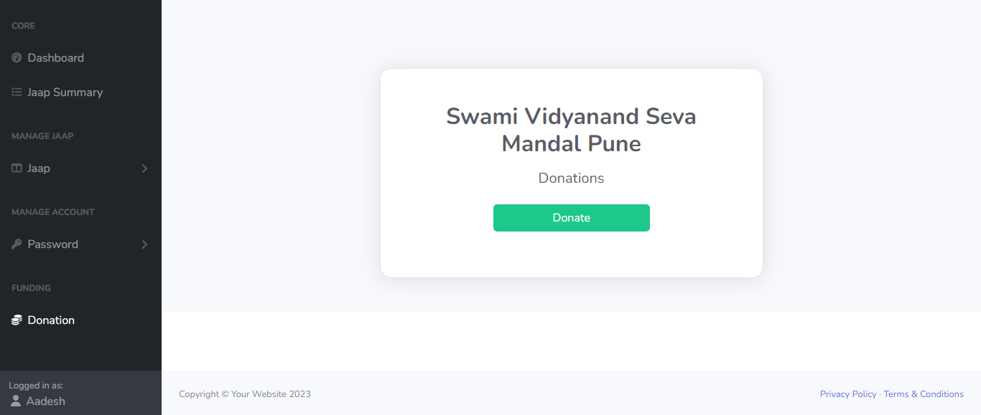

# 4.1 Code Snippets

**Chapter 4: Coding**

<?php include('includes/header.php'); ?>

<div class="container-fluid px-4">

<h1 class="mt-4">Dashboard</h1>

<div class="row">

<?php alertMessage(); ?>

<ol class="breadcrumb mb-4 px-3">

<li class="breadcrumb-item active">Jaap</li>

</ol>

<div class="col-md-3 mb-3">

<a class="link-unstyled text-decoration-none" href="ongoingJaap.php">

<div class="card card-body bg-primary p-3 text-center">

<p class="text-sm mb-0 text-capitalize text-white fw-bold">Ongoing Jaap</p>

<h1 class="fw-bold text-white mb-0 ">

<?php

$memberId =$_SESSION['LoggedInMember']['id'];

$status = mysqli_query($conn, "SELECT j.*, s.CreatedOn AS SubscriptionDate FROM tblsubscribed s JOIN tbljaap j ON j.id = s.JaapId WHERE s.MemberId = '$memberId' ORDER BY s.CreatedOn DESC;");

if ($status) {

if (mysqli_num_rows($status) > 0) {

$totalCount = mysqli_num_rows($status);

echo $totalCount;

} else {

echo '0';

}

} else {

echo 'Something Went Wrong!';

}

?>

</h1>

</div>

</a>

</div>

<div class="col-md-3 mb-3">

<a class="link-unstyled text-decoration-none" href="jaap.php">

<div class="card card-body bg-primary p-3 text-center">

<p class="text-sm mb-0 text-capitalize fw-bold text-white">Total Jaap</p>

<h1 class="fw-bold mb-0 text-white">

<?= getCount('tbljaap'); ?>

</h1>

</div>

</a>

</div>

<hr>

<ol class="breadcrumb mb-4 px-2">

<li class="breadcrumb-item active">Total Jaap Counts</li>

</ol>

<div class="container-fluid px-4">

<div class="row">

<?php

// Fetch JaapName from tbljaap where status=0

$memberId =$_SESSION['LoggedInMember']['id'];

$jaapQuery = mysqli_query($conn, "SELECT j.*, s.CreatedOn AS SubscriptionDate FROM tblsubscribed s JOIN tbljaap j ON j.id = s.JaapId WHERE s.MemberId = '$memberId' ORDER BY s.CreatedOn DESC;");

if ($jaapQuery) {

while ($jaapRow = mysqli_fetch_assoc($jaapQuery)) {

$jaapId = $jaapRow['id'];

$jaapName = $jaapRow['JaapName'];

// Fetch total JaapCount from tbljaapdetails for the current JaapName

$jaapCountQuery = mysqli_query($conn, "SELECT SUM(JaapCount) AS TotalJaapCount FROM tbljaapdetails WHERE JaapId=$jaapId");

$jaapCountRow = mysqli_fetch_assoc($jaapCountQuery);

$totalJaapCount = isset($jaapCountRow['TotalJaapCount']) ? $jaapCountRow['TotalJaapCount'] : 0;

// Display a card for each JaapName

?>

<div class="col-md-3 mb-3">

<a class="link-unstyled text-decoration-none" href="jaap-enter.php?id=<?= $jaapId ?>">

<div class="card card-body bg-primary p-3 text-center">

<p class="text-sm mb-0 fw-bold text-white"><?= $jaapName ?></p>

<h1 class="fw-bold mb-0 text-white">

<?= $totalJaapCount ?>

</h1>

</div>

</a>

</div>

<?php

}

} else {

echo "Failed to fetch JaapName";

}

?>

</div>

</div>

</div>

<?php include('includes/footer.php'); ?>

**Chapter 5: Testing**

* **Unit Test Plan**

**1. Introduction**

This document outlines the unit test plan for the Jaap Counter System, a web application built using HTML, CSS, and PHP. The purpose of unit testing is to validate that individual units of source code work as expected. This test plan includes test cases for key components and functionalities of the system.

**2. Scope**

* User Registration and Authentication
* Jaap Creation and Subscription
* Jaap Count Entry and Editing
* Monthly Jaap Count Reporting
* Total Jaap Count Aggregation
* User Profile Management
* Community Engagement Features
* Admin Panel for System Management and Moderation

**4. Test Environment**

* **Web Server:** Apache
* **Database Server:** MySQL
* **Languages:** HTML, CSS, PHP
* **Tools:** PhpUnit (for PHP testing), Browser developer tools for front-end testing
* **Browsers:** Chrome, Firefox, Edge.

**5. Test Data**

Sample data for users, jaaps, and jaap counts will be created to simulate real-world scenarios

during testing.

**6. Assumptions**

* The environment is properly set up with the necessary software and configurations.
* All dependencies and libraries required by the system are installed and configured.

**7. Responsibilities**

* **Testers:** Responsible for executing the test cases and recording results.
* **Developers:** Responsible for fixing any issues identified during unit testing.
* **Project Manager:** Oversees the testing process and ensures timely resolution of issues.

**8. Approval**

This test plan is approved by the project stakeholders and will be used as a guideline for the unit testing phase of the Jaap Counter System project.

* **Test Cases:**

|  |  |  |  |  |
| --- | --- | --- | --- | --- |
| **Test Case ID** | **Test Case Description** | **Expected Result** | **Actual Result** | **Pass/Fail** |
| TC001 | Member Registration with valid details | Member account is created, and wait for User to accept. | Member account is created, and wait for User to accept by redirected to the login page. | Pass |
| TC002 | Member Registration with invalid details | Display error message. | Appropriate error message is displayed | Pass |
| TC003 | Member Login with valid credentials | Member successfully logged in. | Member is successfully logged in and redirected to the dashboard | Pass |
| TC004 | Member Login with invalid credentials | Display Error message. | Appropriate error message is displayed and member is redirected to the login page | Pass |
| TC005 | Jaap Creation with valid details | Jaap is created and saved in the database. | Jaap is created and saved in the database with success message. | Pass |
| TC006 | Jaap Creation with missing details | Error message is displayed | Appropriate error message is displayed | Pass |
| TC007 | Viewing a created Jaap | Jaap details are displayed correctly | The system prevented the user from entering Jaap counts outside the specified date range. | Pass |
| TC008 | Subscribing to a Jaap | Jaap subscription is saved, and user is added to the jaap | The system only accepted numeric input for the Jaap counts. | Pass |
| TC009 | Entering Jaap counts for a subscribed Jaap | Jaap count is saved and displayed correctly | The system only allowed authenticated users to access the Jaap Counter System. | Pass |
| TC010 | Editing Jaap counts | Edited jaap count is updated and displayed correctly | The system only allowed users to perform actions they were authorized to do. | Pass |

**Chapter 6: Limitations of Proposed System**

# Drawbacks and Limitations:

# Dependency on Technology:

# The Jaap Counter System relies heavily on technology and internet connectivity. Users in areas with limited access to technology or unstable internet connections may face challenges in accessing the system consistently.

# Privacy Concerns:

# Storing personal spiritual practices and data online may raise privacy concerns for some users. Despite implementing security measures, there is always a risk of data breaches or unauthorized access, potentially compromising the privacy of users' spiritual practices.

# User Adoption and Engagement:

# Encouraging users to adopt the system and maintain consistent engagement with their spiritual practices may be challenging. Some users may prefer traditional pen-and-paper methods or be hesitant to share their spiritual journey online due to privacy or cultural reasons.

# Customization Complexity:

# While the system offers customization options for creating and managing jaaps, the process may be complex for users with limited technical proficiency. Simplifying the user interface and providing clear instructions may help mitigate this limitation.

# Limited Personalization:

# Despite offering customization options, the system may not fully cater to the diverse spiritual preferences and practices of all users. Some individuals may require additional features or flexibility that the system does not currently provide.

**Chapter 7: Proposed Enhancement**

# Proposed Enhancement:

The System has adequate scope for modification in future if it is necessary.

* + - **Offline Functionality:** Introducing offline capabilities, such as offline jaap count entry and synchronization, would improve accessibility and usability for users in areas with limited internet connectivity.
    - **Customizable Privacy Settings:** Implementing customizable privacy settings would allow users to control the visibility of their jaap counts and other personal information, addressing privacy concerns while maintaining a sense of community.
    - **Integration with Wearable Devices:** Integrating the system with wearable devices capable of tracking biometric data, such as heart rate variability, could provide users with additional insights into the physiological effects of their spiritual practices.
    - **Enhanced Community Features:** Expanding community features, such as forums, live events, and mentorship programs, would further foster a sense of belonging and support among users.
    - **Advanced Analytics and Insights:** Developing advanced analytics capabilities to provide users with personalized insights and recommendations based on their jaap practice and behavior patterns would enhance user engagement and satisfaction.

**Chapter 8: Conclusion**

# Conclusion:

# In conclusion, the Jaap Counter System represents a valuable tool for individuals seeking to integrate spiritual practices into their lives. By harnessing the power of technology, the system provides users with a convenient and accessible platform for chanting mantras or jaaps, tracking their progress, and engaging with a supportive community.

# While the system may have some limitations, such as dependency on technology and privacy concerns, future enhancements hold the promise of further improving its usability, effectiveness, and inclusivity.

# Overall, the Jaap Counter System stands as a testament to the transformative potential of combining ancient spiritual practices with modern technology to promote mental well-being and spiritual growth.

**Chapter 9: Bibliography**

# Bibliography:

* ChatGPT for problem solving.
* Wikipedia.com.
* Phptpoint.com.
* Youtube.com.

**Chapter 10: Appendix- Cost Sheet**

**Appendix – Cost Sheet**

|  |  |  |
| --- | --- | --- |
| **Category** | **Description** | **Cost (in INR)** |
| Learning and Courses | Udemy / Coursera courses | 599 |
| Api costs | Payment gateway (6 months) | 0 |
| Wi-Fi and Internet | High Speed internet | 7000 |
| Software and tools | IDE, Design Tools, Testing Tools | 0 |
| Hoisting and Infrastructure | Cloud Hosting, Database, CDN | 0 |
| License and Subscriptions | Web fees | 0 |
| Marketing and Promotion | Initial Campaign | 0 |
| Miscellaneous Expenses | Contingency | 0 |
| **Total Estimated Cost** |  | **7599** |